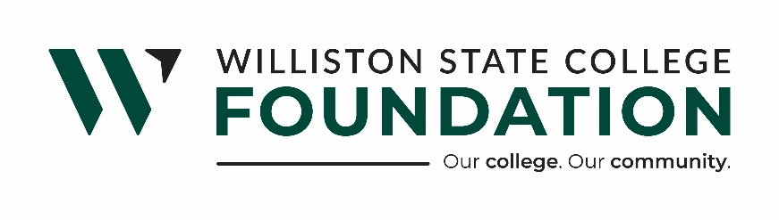

WSC FOUNDATION BOARD OF DIRECTORS REGULAR MEETING
MINUTES
WILLISTON STATE COLLEGE - ALUMNI ROOM | APRIL 15, 2025 |11:30 p.m.

WSC Foundation Mission Statement:

Williston State College Foundation is dedicated to advancing the college’s mission by securing financial support and fostering meaningful connections with alumni, donors, and the surrounding communities.

Present: Board Members Ward Koeser, Mark Barstad, Lee Murphy, Lance Olson, Bill Gathman, Melanie Stillwell, Jory Meyer, Brandon Johnson, Jackie Lee, and Taylor Olson.
WSCF Staff: Executive Director, Hunter Berg, and Chief Financial Officer Laurie Furuseth.
WSC: Dr. Zahi Atallah, VP of Academic Affairs and Deborah Halvorson, VP of Business Services

Absent: Board Members: Katie Kringen
WSCF Donor Relations and Community Outreach Coordinator, Kristina Kitchens and WSC President, Dr. Bernell Hirning
President Taylor Olson called the meeting to order at 11:36 am.

Five students from the WSC Personal Investing class presented on the investments they have been studying and investing in as a class. The Foundation provides the funding for the student-led investments.

Deborah Halvorson, WSC VP of Business Services, introduced herself and provided a Legislative update. She discussed the various requests of WSC and the status of those requests.

Dr. Atallah presented an Academic update, describing new programs related to Healthcare. Following his presentation, he led a tour of the current Nursing area and, along with Gail Raasakka, WSC Nursing Coordinator, demonstrated the new Adult Simulator and Anatomage Table.

Motion to approve the Consent Agenda as follows made by Director Ward Koeser and seconded by Director Lance Olson. Motion carried.

- Consent Agenda:
- Minutes dated March 27th, 2025

Motion to approve the Financial Statements as follows, made by Jory Meyer and seconded by Director Melanie Stillwell. Motion carried.

- Financial Statements
  - Williston State College Foundation
  - WSC Supporting Foundation
  - WSC Housing LLC
  - WSC Charitable Gaming

- Updates:

Dr. Hirning, WSC President, Update
- No Update
CFO, Laurie Furuseth Update:
- No Update
Donor Relations and Community Outreach Update:
- No Update
Hunter Berg, WSCF Executive Director, Update:
- Nelson Grain – Four charitable beneficiaries met and agreed to make a counteroffer for the sale of shares to the majority owner. Hunter will present the offer and report back to the other charities.
- Turf Project – Construction is ongoing
- Healthcare Training Facility – Construction is ongoing. Hunter will see if we can schedule a tour of the facility.

Old Business:
- None
New Business:
- Clark’s Table – Discussed ownership of and responsibility for Clark’s Table. Perhaps it could be addressed in the WSC/WSCF agreement, which is updated and reviewed annually. It was moved by Mark Barstad, seconded by Brandon Johnson, and approved to accept Clark’s Table as a gift from David Njos, if offered.
- Casino Night will be held on April 26th in the Well.

As there was no other business, the meeting adjourned at 12:52 p.m.

Respectfully submitted,

Hunter Berg
Executive Director

